Supports

What are Supports?
Supports are a sacrificial material that is used to hold up and support a part while it is being printed. Supports are often the small material as the actual part but are printed in a weaker quality so that they may be broken off or cut off after the part is finished printing. Some printers are able to print supports in different materials then the actual part which makes them easier to remove in the end.

When to use Supports?
Supports are need in a material whenever there is an overhang or whenever there is nothing below a part for the material to be deposited on during a build. Not all overhangs need supports however. The golden rule for whether or not supports are necessary or not is: If the overhang exceeds an angle of 45 degrees then supports are needed during the build, if it does not then supports are not needed.

Advantages of Supports?
Supports can ensure that a part is printed correctly. Without supports, a print with any kind of overhang (that exceeds 45 degrees) will not print correctly or will be printed with deformities. Supports enable a printer to print diverse and complicated geometries for parts that otherwise would be impossible to print.

Disadvantages of Supports?
Supports can sometimes be difficult to break off depending on the shape and geometry of a part. For example, if a part has an internal geometry that need supports, those supports may be difficult to break off. Also, when supports are needed, a print will take longer to print the part due to the need to add more material. When designing a part, it is often a good idea to design it so that supports are not needed during the print but this is not always possible.
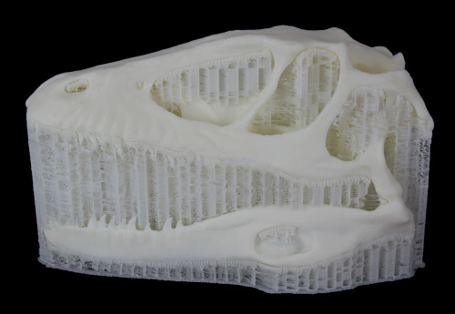

Courtesy of America Makes, the National Additive Manufacturing Innovation Institute, Youngstown, OH

